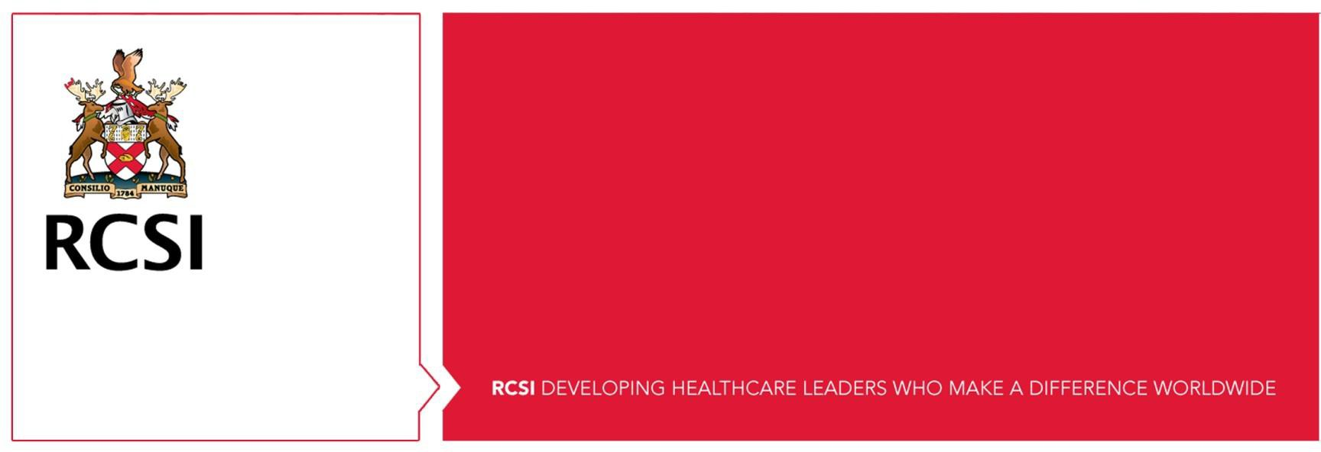

**RCSI** Dublin

Interview Questions for PhD in <Topic>

<PI> - <Research Group>

# Job Specification:

<Include Job spec summary so that interviewers know what the PhD project is about. 4-5 lines>

# Interview Format:

The candidate is required to give a 5 minute presentation (Title slide + 3 slides) with the title **‘Why I want to do a PhD Investigating <topic>**’. The presentation will be followed by 15 minutes of interview questions.

# Specific requirements, experience and knowledge to look for from presentation:

* <criteria 1>
* <criteria 2>
* <criteria 3>
* Show a genuine interest and passion for this area

# Questions;

PhD Related – <PI>

1. Why did you first become interested in science and pursuing a career in science?
2. In your opinion, what are the top three qualities required to undertake a PhD? Why do you think it is the right option for you?
3. Resilience and perseverance are essential attributes during a PhD – can you give us an example where you were challenged and overcame it? (It doesn’t have to be science related?)

Project Specific – <co-PI or postdoc in lab>

1. <content specific Q1>
2. Can you talk us through the technical skills you have learnt and how you could apply them to this PhD. What skills do you not yet have but would like to learn?
3. In the lab, if you were faced with continuously failing experiment – what path would you take to overcome it?

People Skills - <co-PI or postdoc in lab>

1. From your experience in the lab, can you tell us how do you organise your time and prioritize your work?
2. Give an example of a successful team project you were part of and your role in it. It could be from outside the laboratory/science.
3. What would you do if you noticed your fellow PhD student who works beside you in the lab was struggling with issues related to their PhD and appeared unhappy? What would be your advice to them?

Wrap up – <external interviewer>

1. Have you any questions for us in relation to this PhD or RCSI?