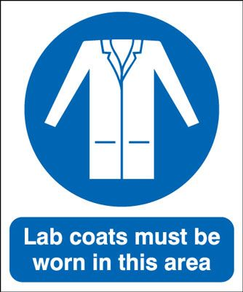
Health & Safety Laboratory Induction

Working in laboratories:

Laboratory (howie type) coats must be worn at all times when in a lab; sleeves fully down, covering wrists.

Additional protective items i.e. nitrile gloves, safety glasses and respiratory masks should be worn if required - see relevant Safety Data Sheet (SDS). NOTE: Face masks issued at reception areas during COVID-19 pandemic are not respiratory masks and not considered PPE.

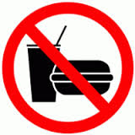
Do not wear shorts / have bare legs or open-toed shoes (e.g. sandals) in labs.

Do not store or consume food or drinks in labs.

Label chemical waste with specific contents and maintain labels on chemical containers received from manufacturers. Label secondary containers. Replace old and deteriorated labels.

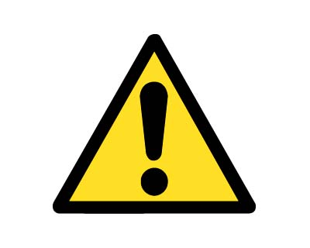
Segregate chemicals properly. Store acids in an acid cabinet or in a plastic container (tub). Store nitric acid separately.

Dispose of unwanted chemicals through the waste disposal procedure. Contact your PI and/or Lab Manager for further information. Keep chemical waste containers closed.

Chemical fume hood sashes should be kept closed whenever possible. Maintain the minimum possible opening when working. Limit storage in hoods to essential items only.

Secure gas cylinders properly and keep safety caps on cylinders when not in use.

Remove clutter and practice good housekeeping. Keep exits and aisles clear.

Risk Assessments and associated SDS can be found in ___________________________________. Please refer to these before using any chemicals/equipment. A risk assessment (RA) must be carried out for any new chemicals / equipment / task. RA templates including COVID-19 general RA template can be found on staff portal here.

Working alone in a laboratory:

If you are working at the weekend / outside normal hours you must:

Complete Out of Hours/Lone Worker Risk Assessment in advance (available on staff portal here) and have this signed by your PI & send to your Lab Manager, security@rcsi.ie and safety@rcsi.ie

No high risk work should be carried out when you are working alone in the Lab. List of high risk work in Lone working procedure.

Go to reception desk / security office to sign in and out.

NOTE: Hours of work, supervised, for Undergraduate Students, including Summer Students are 9am – 6pm. No out of hours or unsupervised work allowed at any time.

In the event of an incident / injury / suspected case of COVID-19:

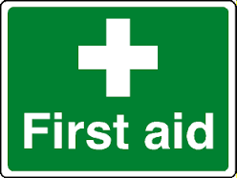
RCSI Emergency Contact No: St. Stephens Green = 01 4022219; Beaumont ERC = 01 8093700

First Aid kit located in ___________________________________________________________

First Aiders in your Lab are ______________________________________________________

Notify Supervisor immediately of any incident.

Fill out the injury / incident report form and send to safety@rcsi.ie.

In the event of fire:

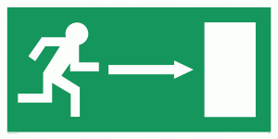
Leave by the nearest emergency exit route & exit the building – do not use the lift & close all doors behind you.

Assembly Point:

St. Stephens Green = Opposite Swan Pub / Unitarian Church;

Beaumont ERC = Car Park C.
- Do not re-enter the building for any personal items & until instructed that it is safe to do so.
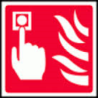
- If there is a fire in the lab and the alarm hasn’t gone off – break / press the nearest red break glass unit (B.G.U) and proceed to the nearest emergency exit immediately.

In the event of a chemical spill:
- Notify Supervisor or other personnel in the lab for assistance.
- If you are unclear about the risks associated with the chemical, consult SDS before clean-up.
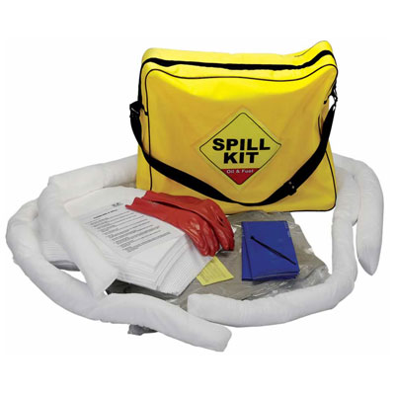
- Ensure that you are wearing suitable protective clothing (including a respirator if required) as indicated on the SDS.
- Do not pick up broken glass by hand – use the brush/scup & dustpan & dispose of in the appropriate bin.

In the case of a small spill (<1litres), contain the spill using the chemical spill kit.

If the liquid spill is more than >1litre, contact the Chemical Spill Response Team at: St. Stephens Green 01 402 2219; Beaumont ERC 01 809 3700.

In the case of a solid/powder spill, vacuum or add liquid (non-water reactive chemicals) so as not to raise dust and dispose of in bag provided in the chemical spill kit. Mop up remaining powder with damp tissue and dispose of in same bag.

In the event of a very serious chemical spill and risk of fire, initiate RCSI Emergency Evacuation Procedure – break the nearest red break glass unit (B.G.U) and proceed to the nearest emergency exit immediately (with SDS if possible).

Fill out an Incident Report Form and send to safety@rcsi.ie.

Waste Management:
Make yourself familiar with all the waste bins in your lab before commencing work. See appendix 1 in HSP_15 Waste Management Procedure for information.
If in doubt, ASK!
If you have any questions or concerns about issues relating to Health & Safety in the lab please contact your Lab Supervisor / PI or your Health & Safety Representative.

For further information on Health & Safety; for Policies, Procedure & Forms go to Staff Portal: http://staff.rcsi.ie/administration-and-support/estate-services/health-and-safety

Health & Safety Instruction & Record of Training:
In the interest of my own health & safety I have received a laboratory orientation and I have read, understood and agree to put into practice the above Health & Safety information in the lab(s) I am working in.

Name:
Signature:
Start Date:
Contract dates:
Your Supervisor / PI is:
Your Health & Safety Representative is:

In addition I have received training in the use of the following equipment:

Equipment Name | Date of Training | Staff Signature | Trained by | Competent to use this equipment without supervision YES / NO?

