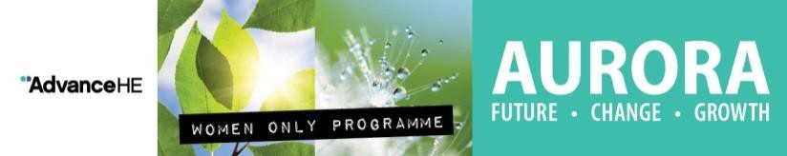

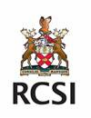**Aurora Programme – Frequently Asked Questions:**

# Q. Who is this programme for?

The programme is designed for women and those who identify as women who work in Academic, Research and Professional Support areas up to Senior Lecturer level or equivalent i.e. anyone not already in Professorial, PI or other Senior Management/Director roles. All applicants must have been employed by RCSI for at least 12 months at the time of application and RCSI must be the main employer.

# Q. How will staff be selected?

Participants are selected by a committee chaired by the RCSI Aurora Champion. Closing date for applications is end of day **on Friday 8th September 2023.**

# Q. Who is the RCSI Aurora Champion?

Prof Zena Moore, Head of School of Nursing and Midwifery is the overall Aurora programme champion and Catriona Campbell, Head of Staff Learning and Development is your contact in HR.

# Q. Is there a limit on the number of people from one department who can apply?

There is no limit on the number of applications that can be put forward but in selecting participants we will endeavour to ensure a spread of participants from all areas of the University - Academic, Research and Professional Services.

# Q. How much does it cost?

Spaces on the Aurora programme are fully funded by RCSI Staff Learning and Development, there is no cost to the participant or their department.

# Q. Is Aurora only for women already in a leadership role?

No, in fact the programme is specifically designed to help early career women think about their future careers and to consider leadership and management as routes to progression.

# Q. Where will the programme take place?

All modules will take place online with the exception of the last newly added networking day which will take place in-person in Dublin. The programme commences in October 2023 and usually has approx. 150 female participants from across all Irish HEIs. All programme dates are listed below:

* **Welcome & Introduction (half day)** - Wednesday, 11 October 2023
* **Identity, Impact and Voice** - Friday, 20 October 2023
* **Core Leadership Skills** - Friday, 17 November 2023
* **Action Learning Set 1** - Tuesday, 28 November 2023
* **Politics & Influence** - Thursday, 14 December 2023
* **Adaptive Leadership Skills** - Thursday, 25 January 2024
* **Your Future In HE (face to face)** - Tuesday, 5 March 2024
* **Action Learning Set 2** - Thursday, 14 March 2024

# Q. How does Aurora relate to Higher Education diversity awards, such as Athena SWAN?

Female career development and mentoring is a major part of Athena SWAN. While there is no direct link between Athena SWAN and Aurora, the programme is entirely complementary to the aims of Athena SWAN in that it supports and encourages the advancement of women in Higher Education.

# What is the time commitment?

*Development Days:*

Aurora consists of seven interlinked days running from 10am to 3pm. Each participant is required to attend each of the Aurora days – 4 development days, 2 days of action learning sets and 1 new additional networking day (9:30am-4pm). The development days focus on the following topics:

* + Identity, Impact and Voice
  + Core Leadership Skills
  + Politics and Influence
  + Adaptive Leadership Skills

*Mentoring:*

All participants in the Aurora programme will be paired with a mentor from within RCSI. Mentoring meetings typically take 1-1.5 hours every 4-6 weeks. Mentor/Mentee training will be provided by Staff Learning and Development to ensure both parties understand their respective roles and get the most out of the programme.

*Self Directed Learning:*

The self-directed learning available to all participants includes articles, videos and various activities and challenges. How much time each participant spends on this really depends on their specific interests and availability however engaging with these materials will enhance your learning experience so we do encourage you to do so.

**Q. What is the role of the mentor?**

The mentor is the in-house support for the Aurora participant outside of the development days and the person who will help you make sense of your own institution’s culture, internal politics and power structures. The mentor will be a more senior colleague who remembers the challenges of career progression, has excellent listening skills and can ask good, open questions to help the individual develop their own problem-solving skills. Mentors can be male or female.

**Q. When will I know if my application is successful?**

This year we aim to get back to all applicants by mid-late September. For applicants who are unsuccessful, it is recommended that this is discussed with their respective Line Manager and forms part of their PDP discussions.

**Q. Where can I get further information:**

RCSI’s Aurora Champion: Prof Zena Moore ([zmoore@rcsi.com](mailto:zmoore@rcsi.com))

Head of Staff Learning and Development: Catriona Campbell ([catrionacampbell@rcsi.com](mailto:catrionacampbell@rcsi.com))

The [Advance HE Aurora page](https://www.advance-he.ac.uk/programmes-events/aurora#Overview) also has a wealth of information on the Aurora programme including testimonials from previous participants.