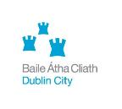 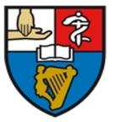

**Charles Lucas Tercentenary Symposium**

*Royal Academy of Medicine in Ireland*

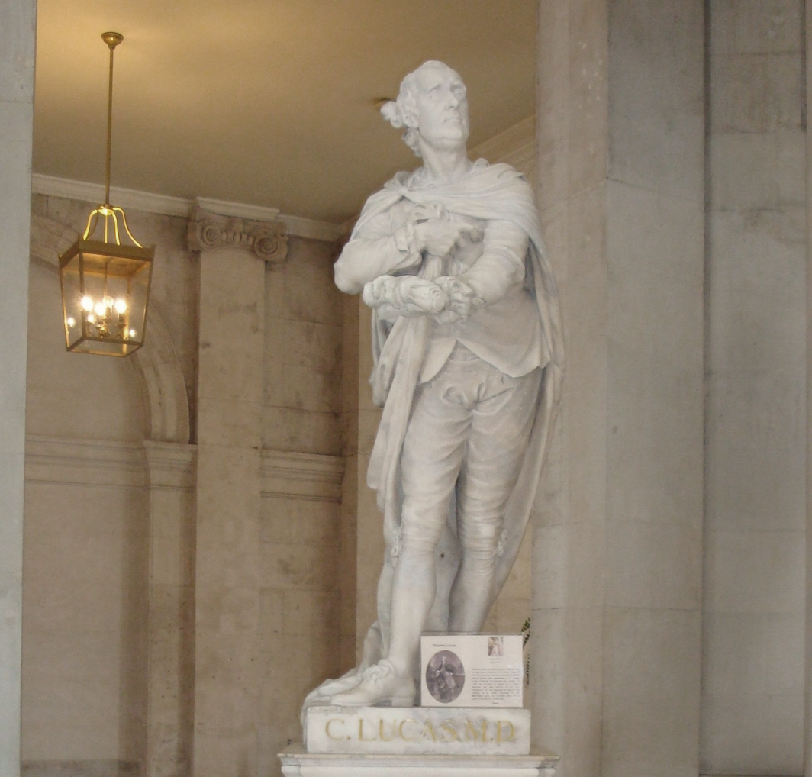

**Wednesday 25 September 2013, 5 pm**

**Council Room, City Hall, Dublin**

**Chair: Professor David Dickson, TCD**

***The Life and Significance of Charles Lucas: An Overview***

**Professor James Kelly, St Patrick’s College/DCU**

***Dublin and Irish Politics in the Age of Charles Lucas***

**Professor Jacqueline Hill, NUI Maynooth**

***Charles Lucas and Patriot Politics in Mid-18th Century Ireland***

**Dr Eoin Magennis, President of the Eighteenth Century Ireland Society**

***The Professionalisation of Medical Practice in Dublin during the Early-17th Century: the Case of Thomas Arthur, M.D.***

**Professor Marian Lyons, NUI Maynooth**

***Charles Lucas and Medical Regulation in 18th Century Ireland***

**Dr Susan Mullaney, RAMI/UCC**

***The ‘Essay on Waters’ and other Medical Writings of Charles Lucas***

**Sean J. Murphy, M.A., Genealogy Teacher, UCD Adult Education**