How to Nominate:

1. Complete nomination form

Section 1 Personal details of nominee and nominator
Section 2 Rationale for nomination

Using specific example(s) where possible, explain why you wish to nominate your colleague for a Dean’s Award.

Nominators are encouraged to review the Selection Criteria (see appendix) prior to completing this section.

2. Once completed, send nomination form by post or email to:

Office of the Dean
Faculty of Medicine and Health Sciences
Royal College of Surgeons in Ireland
123 St Stephens Green, Dublin 2
Email: deansoffice@rcsi.ie

Section 1 (to be completed by nominator)

Name of Nominee:
Faculty/School/Dept:
Job Title:
Location:
Name of Nominator:
Faculty/School/Dept:
Job Title:
Location:
Email:
Telephone:
Date:

Section 2 (to be completed by nominator)

RCSI values the diverse and essential contributions of all staff members who perform a vast array of critical duties that support the College’s commitment to growth and excellence. The Dean’s Award is the College’s opportunity to honour these exceptional accomplishments.

Please explain why you are nominating your colleague for a Dean’s Award. Your narrative should outline the rationale for your nomination and demonstrate your colleagues commitment to achieving growth and excellence giving specific details and examples where possible, using the guiding principles of RCSI’s core values (see appendix):

You may use either descriptive paragraphs or bullet-points to describe your nomination. Please feel free to attach additional pages or supporting documents where necessary.

I’m nominating for a Dean’s Award 2014 because

APPENDIX
Selection Criteria
Nominated individuals should have a proven track record of making significant contributions that exceed the requirements of the job and demonstrate efforts above and beyond the normal duties of their post.

Information provided on the nomination form will be the only source of information, so it is important that your narrative clearly conveys the basis for your nomination.

RCSI’s core values provide a basis for describing your nominee’s commitment to the Strategic Plan 2013 - 2017 growth and excellence.
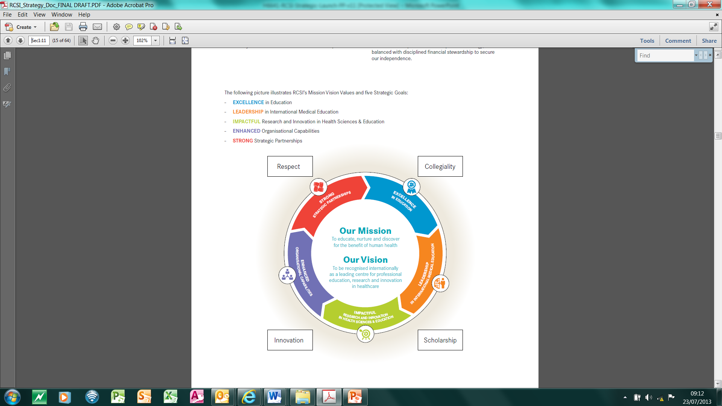

The following are examples of the types of accomplishments that a Deans Award nominee may exhibit.

Core values: Respect, Collegiality, Scholarship and Innovation.
Respect:  - Committed to transparency, integrity and respect for all persons who engage with RCSI  - Values diversity and unique contributions  - Fosters a trusting, open and inclusive environment and treating each person in a manner that reflects RCSI’s values.  - Displays empathy - seeks to see things from others point of view | Collegiality  - Contributes to building a nurturing, social and inclusive community conducive to collaboration and development  - Works collaboratively with colleagues to achieve College goals; contributes to effective work teams  - Builds and maintains relationships and networks  - Communicates effectively  - Solicits input and is willing to learn from others
Scholarship  - Contributes to providing a stimulating and challenging environment that promotes excellence in teaching and learning  - Drives quality and excellence in terms of work practices/ products  - Delivers outputs within prescribed time, cost and quality standards  - Actively seeks out opportunities to improve, learn and develop self  - Stays current in own field of expertise  - Contributes to the learning of colleagues | Innovation  - Generates creative ideas, techniques, solutions  - Contributes to fostering a culture of discovery to create research with impact  - Actively seeks to improve programmes or services  - Strong problem solving orientation  - Demonstrates initiative/ self-direction  - Flexible, adaptive and positive attitude to change  - Keeps abreast of available technology and shows willingness to learn new technology

