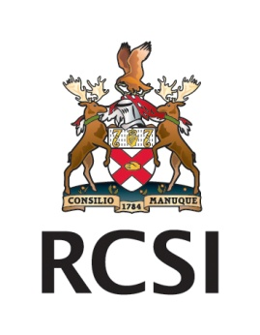

**RCSI Disability Support Service - Lunchtime Workshop**

**Providing an Inclusive Educational Service; Creating an Inclusive Organisation**

**Lunchtime Workshop**

On **December 4th and 5th** RCSI Student Services is hosting a lunchtime workshop on Disability and the Disability Support Service (DSS). Both days will be facilitated by Beverley Webster, Disability and Occupational Rehabilitation Consultant. This is an ideal opportunity to learn more about disability.

**Who Should Attend?**

Anyone interfacing with students at RCSI can benefit from this workshop.

**What Will Be Covered?**

The workshop will explore a range of issues that may impact upon your work with students and on RCSI as an organisation. There will be a particular focus on the definition of Disability, the Disability Support Service (DSS) at RCSI– e.g. What is it? What does it do?; the requirement to provide “Reasonable Accommodation”; What is Reasonable Accommodation? How reasonable is reasonable? Who decides on what is reasonable? The danger of assumptions vs. good practice.

**Workshop Methodology**

The approach will be very practical and applied. There will be a short presentation, followed by working through real cases and looking at the decisions on those cases made by an Equality Officer in an Irish Equality Tribunal. Information packages to take away will be available for each participant.

**How Do I Book a Place?**

Please confirm your place by email to [disability@rcsi.ie](mailto:disability@rcsi.ie) by Friday, 30 December 2013.