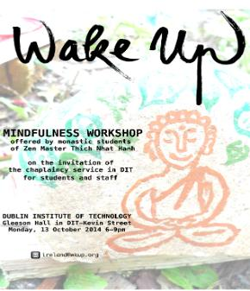

This Workshop is offered by Monastic Students of Zen Master

Thich Nhat Hanh on the invitation of the Chaplaincy Services at D.I.T

Kevin Street

Monday October 13th  6.00 to 9.00 pm

Gleeson Hall DIT Kevin Street.

**Staff and Students from RCSI are welcome**